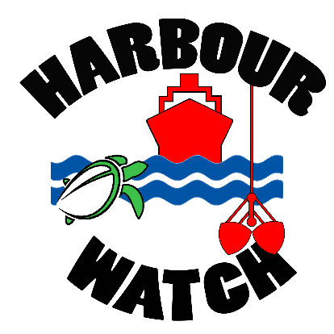
Port Curtis Harbour Watch

Understanding our harbour and catchment waterways
c/o Boyne Island Environmental Education Centre
61 Malpas Street, Boyne Island Qld 4680
Email: harbourwatch@boyneislandeec.eq.edu.au
Website: www.harbourwatch.eq.edu.au
Phone: (07) 4851 0333 Fax: (07) 4851 0300

Application for Booking
If you wish to apply for dates for a visit, this form must be completed. No phone applications will be accepted. Please refer to the Booking Process for Schools Outline for an overview of the booking process. All Bookings are handled through the Boyne Island Environmental Education Centre and are subject to availability of Harbour Watch staff, BIEEC staff and other qualified persons.

PART A: Administration & Logisitics
Name of School: |  |  |  |  |  | A.B.N.:
Postal Address:
Phone Number: |  |  |  |  | Fax Number:
Contact Teacher: |  |  |  |  | Teacher’s Email:
Principal’s Name: |  |  |  |  | Emergency Contact Number:
Year Level: |  |  |  |  | Subject area (Secondary)
Total # of Teachers: |  |  |  |  | # of Additional Adults:
Number of Students: | Female: |  |  |  |  | Male:
Date(s) Preferred: | From: |  |  |  |  | To:
Alternative Date 1: | From: |  |  |  |  | To:
Alternative Date 2: | From: |  |  |  |  | To:
 | Time of Arrival: |  |  |  |  | Time of Depart:
 | At Location: |  |  |  |  | From Location:
PART B: Program Planning
i. Program Focus
Make selections by placing an X next to your preferred activity
Chemistry |  |  | Year Level Science |  |  |  |  | Gladstone Area Studied
Biology |  |  | Marine Science |  |  |  |  | Geography
Earth Science |  |  | Sustainability |  |  |  |  | Environmental Science
Other (please specify):
ii. Program Activities
Consideration to age of students and subject area may vary delivery of activity. All programs are individually designed to suit school requirements. Make selections by placing an X next to your preferred activity.
Water Quality (chemical analysis) |  |  | Substrate Quality (physical) |  |  |  |  | Substrate Quality (chemical)
Plankton |  |  | Benthic Organisms |  |  |  |  | Heavy Metal Concentrations
Microscope Study |  |  | Water Monitoring |  |  |  |  | E.E.I.
Other (please specify):
iii. Sampling Site Location
Make selections by placing an X next to your preferred location(s).
* indicates access to these areas is via large vessel or alternate transportation and further discussions are required.
Auckland Creek |  |  | Wild Cattle Creek |  |  |  |  | Boyne River
South Trees Inlet |  |  | Calliope Rover * |  |  |  |  | The Narrows *
Western Basin * |  |  | Middle Harbour * |  |  |  |  | Outer Harbour *
Harbour Fringes * |  |  | Awoonga Dam * |  |  |  |  | Boyne Island Environmental Education Centre
Other (please specify): |  | School based
iv. Access to sampling site
Make selections by placing an X next to your preferred access to location.
* Indicates limited access in certain areas
** Indicates a cost may be involved to hire BIEEC vessels and Qualified Coxswain to supervise unlicensed students in vessels (please indicate if you require a qualified coxswain)
Land Based Access (no boats required) * |  |  | Own boats (ie. school owned) ** |  |  |  |  | BIEEC boats **
Other (please specify):
v. Timing of Program
Make selections by placing an X next to your preferred access to location.
Day Excursion |  |  | Short Term (Term) |  |  |  |  | Long Term (Semester-Year)
Other (please specify):
PART C: Curriculum Planning
To assist Harbour Watch staff in maximising the learning potential of your program, could you please provide the following information.
What are your learning outcomes for the program?
How will the learning outcomes be assessed?
How will the assessment be reported?
What work will you be undertaking prior to the program?
What work will you be undertaking after the program?
Any other details to assist with planning the program
To assist in the planning of your program could you please supply an electronic copy of student assessment task or other relevant work material? If yes, please forward in an email to harbourwatch@boyneislandeec.eq.edu.au

